
Name: TEACHER:

YEAR 11 SEMESTER TWO 2003

HUMAN BIOLOGY EXAMINATION

Time Allowed For This Paper

Reading Time : 10minutes
Working Time : 3 hours

PART 1 : Multiple Choice – 40 Questions – 80 marks
Answer the multiple choice questions by crossing out the letter of your choice on the answer sheet provided.
Use a 2B pencil here.

PART 2 : Short Answers – 10 Questions – 80 Marks
Answer the questions in the spaces provided. Answers are to be in BLUE or BLACK ink.
GRAPHS and DRAWINGS to be in pencil and labelled in ink.

PART 3 : Extended Answer – 2 Questions – 40 Marks
Answer any two questions from the three questions in this section. Write the answer on the lined paper provided.

PART ONE: MULTIPLE CHOICE - 40 QUESTIONS.

- Amino Acids resulting from the digestive breakdown of protein are mainly absorbed in the:
  - Stomach
  - Pancreas
  - Small intestine
  - Large intestine

- Which of the following statements about the development of the fertilised ovum is INCORRECT?
  - Fertilisation produces a zygote which contains 46 chromosomes.
  - The fertilised ovum undergoes several mitotic divisions.
  - The morula develops a cavity and becomes a blastocyst.
  - The blastocyst implants in the endometrium 3 weeks after fertilisation.

- Benign tumours are likely to cause death in a person by:
  - Spreading throughout the body via the lymphatic and circulatory system.
  - Consuming energy at such a rate so as to prevent the normal functioning of surrounding cells.
  - Enlarging to such an extent, whereby, due to size they block off blood vessels or press against vital organs such as the brain.
  - Producing toxic substances released into the blood.

- Which of the following statements about pregnancy is INCORRECT?
  - During late pregnancy women urinate more often because the expanding uterus exerts pressure on the bladder.
  - The lungs of the foetus are collapsed until birth.
  - The chorion is made from the mother’s cells.
  - The umbilical vein carries oxygenated blood from the placenta to the foetus.

- Which of the following groups of nutrients are absolutely essential for human survival?
  - Fats, proteins and vitamins.
  - Carbohydrates, vitamins and minerals.
  - Vitamins, minerals and proteins.
  - Carbohydrates, fats and proteins.

- Striated muscle fibres are noted for their ability to contract powerfully and quickly, however, these contractions can’t be maintained for long periods of time. This would mean that striated muscle would be found in:
  - The pyloric sphincter muscle.
  - The ventricles of the heart.
  - The biceps muscle.
  - The walls of the arteries.

- Refer to the graph below to obtain information for questions 7 and 8.
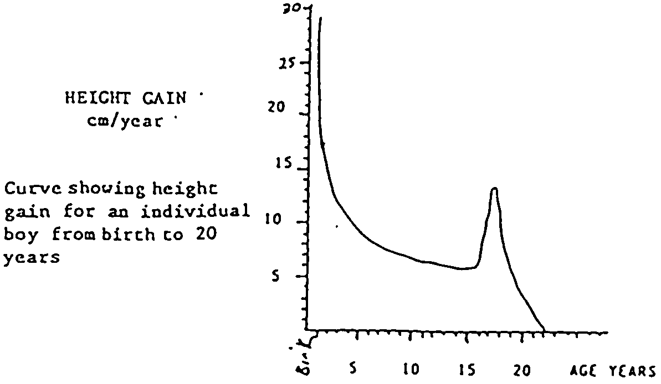
The boy’s maximum growth rate occurred during:
  - 0 – 2 years
  - 4 – 6 years
  - 10 – 12 years
  - 14 – 16 years

- A similar graph drawn of the height gain of a particular girl between the ages of 8 and 20 years would be:
  - To the right of the present graph line.
  - To the left of the present graph line.
  - The same as the present graph line.
  - Impossible to state with certainty.

- The foetus is most susceptible to viral infections and drugs which would cause malformations during the:
  - First 3 months of pregnancy.
  - Period between months 3 – 9 of pregnancy.
  - Period between months 3 – 6 of pregnancy.
  - Period between months 6 – 9 of pregnancy.

- Food tests were completed with the following results.
(i) Benedict’s solution produced a bright red colour change.
(ii) Iodine produced a blue/black colour change.
(iii) Millon's produced no reaction.
(iv) Brown paper did not become transparent.

From the data above, which of the following components were present in the food being tested?

- Glucose, lipid, starch and protein.
- Glucose and starch only.
- Protein, glucose and starch only.
- Lipid, starch and glucose only.

- Cardiovascular disease is presently the most serious health problem in Australian society. The commonest cause of this disease is hypertension (high blood pressure). Which of the following suggestions is recommended to prevent hypertension?
  - Moderately smoking, drinking and eating anything.
  - Regular exercise and a careful dietary program.
  - Limiting energy and salt intake, regular daily exercise, relaxation sessions and no smoking.
  - None of the above.

Questions 12 and 13 refer to the following diagram.

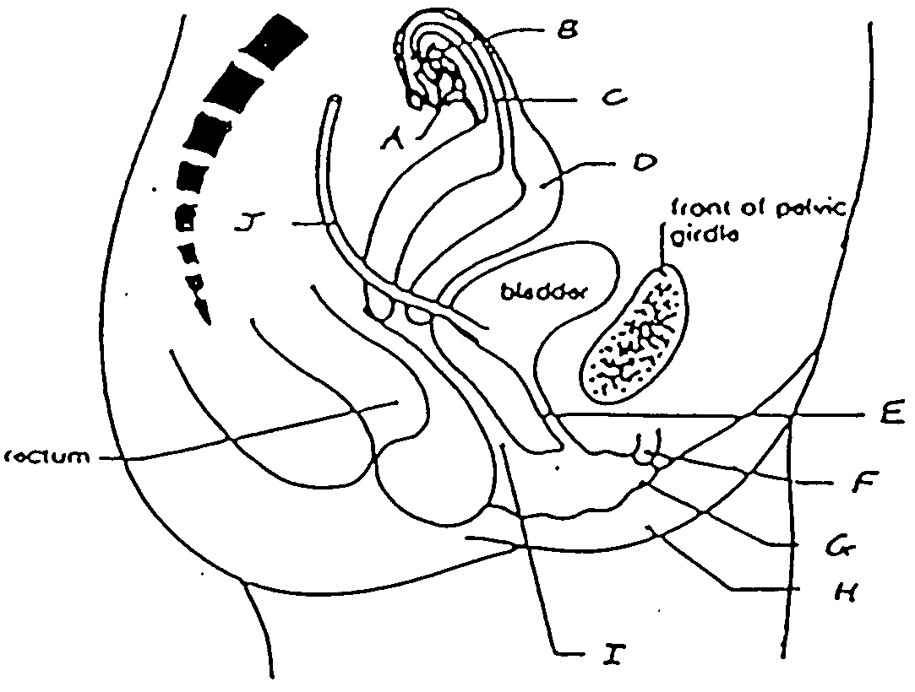

- Structures D, E and I are respectively identified as:
  - Vagina, clitoris, labia.
  - Uterus, ureter, urethra.
  - Vagina, fallopian tube, uterus.
  - Uterus, urethra, vagina.

- Structure C is:
  - The site of gamete combination.
  - Receives sperm of the male.
  - The site of embryo development.
  - Eliminates urine from the body.

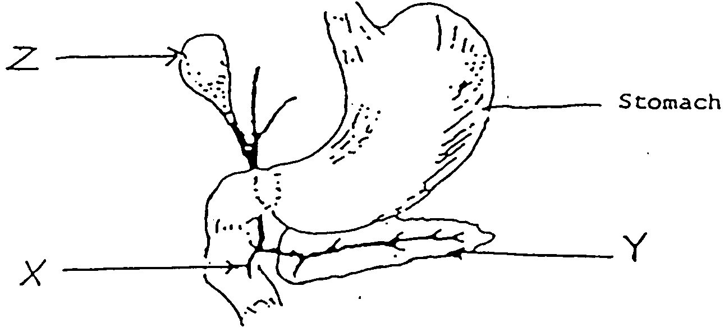

- In the above diagram, which of the following pairs of substances pass through structure X?
  - Pancreatic juice and bile.
  - Bile and chyme.
  - Amylase and mucous.
  - Bile and hydrochloric acid.

- Which of the following are necessary for protein synthesis?
  - Amino acids, DNA, ADP and phosphate.
  - Amino acids, ATP, phosphate and energy.
  - Amino acids, DNA, enzyme and energy.
  - Amino acids, ADP, enzyme and phosphate.

- Spermatogenesis and oogenesis are processes occurring in male and female reproductive organs respectively. They are necessary processes because:
  - They produce enzymes for reproductive functions.
  - Without these processes humans would not survive.
  - They are vital in producing haploid cells.
  - They are vital in producing diploid cells.

- The corpus luteum is responsible for the secretion of:
  - Cortisone.
  - Oestrogen.
  - Luteinising hormone.
  - Progesterone and oestrogen.

- Which of the terms below refer to observable physical differences between males and females?
  - Primary sex characteristics.
  - Tertiary sex characteristics.
  - Dimorphism.
  - Secondary sex characteristics.

- Which of the following is a method that cannot lead to the spread of HIV?
  - Having unprotected sex.
  - Blood transfusions in countries where blood is not tested.
  - Toilet seats in public toilets.
  - Sharing needles and syringes.

Graph showing growth rates of human organ systems

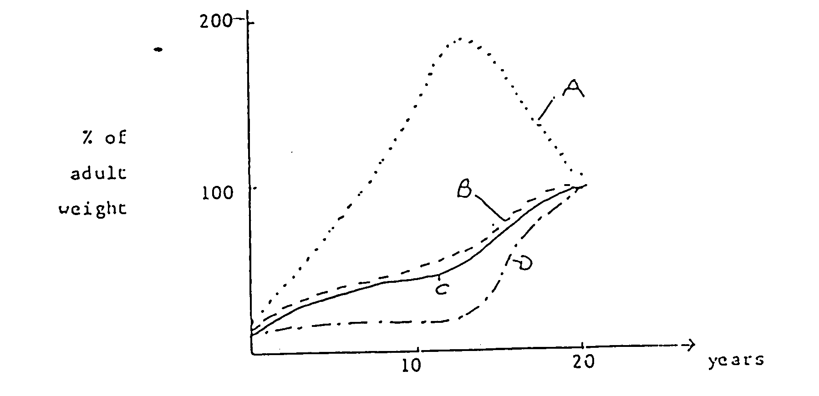

- In the graph above, line A and D represent respectively, growth of:
  - The reproductive and nervous systems.
  - The immune and nervous systems.
  - Cartilage in the skeleton and total body weight.
  - The immune and reproductive systems.

Questions 21 and 22 refer to the following diagram.
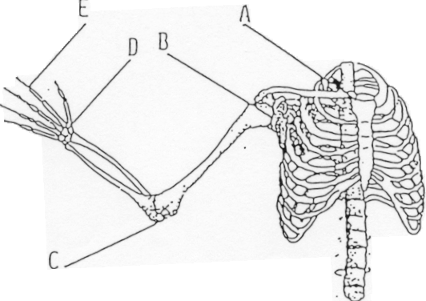

- Which of the letters below represent a hinge joint?
  - A
  - B
  - C
  - D

- Which of the above pairs of movements is possible at the joint named C?
  - Flexion and adduction.
  - Extension and rotation.
  - Extension and adduction.
  - Flexion and extension.

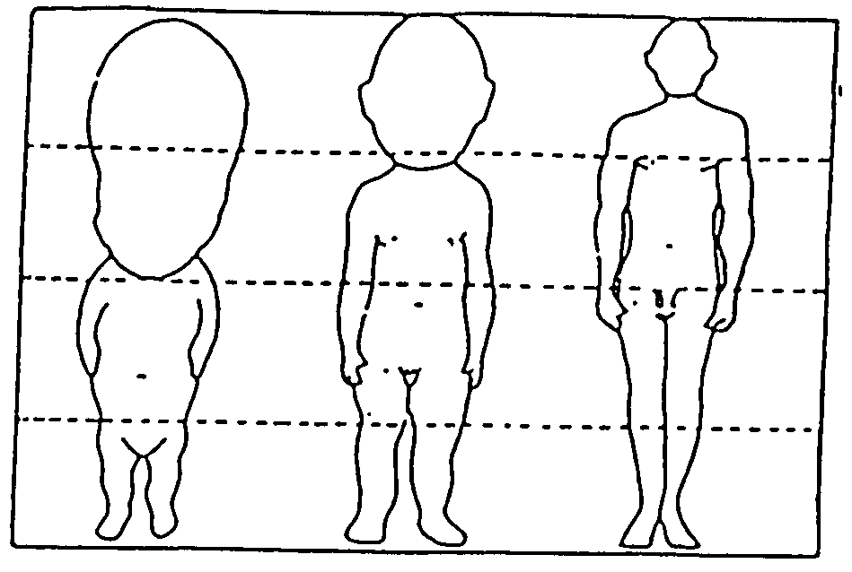

- The above diagram shows 3 stages in human development. The proportions have been made equal. Which of the following statements is INCORRECT?
  - The length of the legs increases in proportion to the body parts.
  - The parts of the body develop at different rates.
  - The head is decreasing in size.
  - The arms increase in proportion to the body.

- In mammals, most enzymes cease to function when the pass from one part of the alimentary tract to another. Which one of the following statements is the most likely explanation for the generalisation?
  - Different substrates require a variety of enzymes.
  - Enzymes are affected by temperature changes.
  - Some enzymes will only operate in a relatively narrow pH range.
  - Absorption of the products of digestion has occurred and enzyme reaction is no longer necessary.

- Which of the following best describes osmosis?
  - The movement of molecules from an area of higher concentration to one of lower concentration.
  - The ability of a membrane to regulate the molecules passing through it.
  - The movement of water through a differentially semi-permeable membrane.
  - The process of transporting molecules against a concentration gradient.

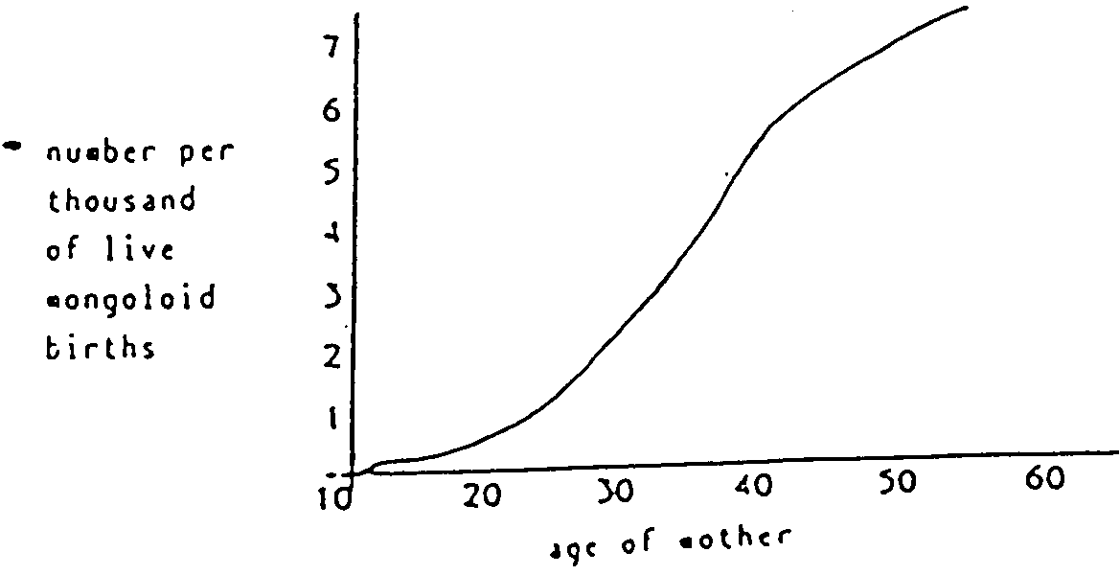

Number per thousand of live mongoloid births

Age of mother

- From the information contained in the graph above, which of the following conclusions is INCORRECT?
  - Young women (less then 25) are unlikely to give birth to a mongoloid baby.
  - The frequency of Mongoloid births increases as the mother’s age increases.
  - Women at age 40 years of age have a 1 in 200 chance of having a Mongoloid child.
  - Live Mongoloid births do not occur across the range of mother’s ages.

- The following diagrams indicate the levels of oestrogen and progesterone during a normal menstrual cycle. For successful implantation of a possible fertilised ovum, which one of the graphs indicates the appropriate hormone levels required?

(a)
oestrogen

progesterone

1 14 28
time(days)

(b)
oestrogen

progesterone

1 14 28
time(days)

(c )
oestrogen

progesterone

1 14 28
time(days)

(d)
oestrogen

progesterone

1 14 28
time(days)

- Which of the following contains a body part that’s not involved in digestion?

  - Stomach, Liver and gall bladder.
  - Gall bladder, Liver and colon
  - Stomach, duodenum and Liver
  - Stomach, trachea and Liver

- A patient was diagnosed with the following symptoms: soft bones especially the legs which continued to bow when walking. This person would most likely be suffering from?
  - Spina bifida.
  - Rickets.
  - Scurvy.
  - Lack of iron in diet.

The following diagram refers to questions 30 and 31.
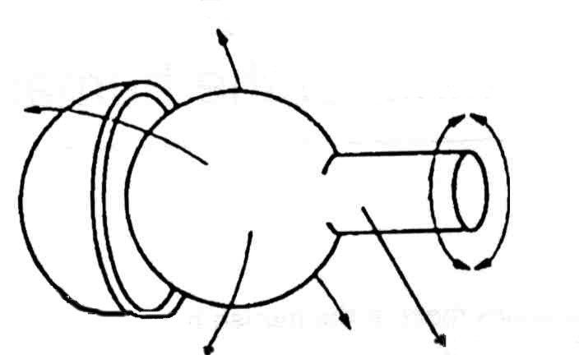

- The diagram above is an example of which type of joint?
  - Ball and socket.
  - Pivot.
  - Hinge.
  - Gliding.

- Where in the body would you find this joint?
  - Elbow.
  - Neck.
  - Knee.
  - Wrist.

- The term ‘coitus interruptus’ refers to which of the following statements?
  - The application if a chemical that kills the male sperm after ejaculation.
  - The sudden feeling of well being that accompanies ejaculation.
  - The withdrawal of the penis before ejaculation.
  - The movement of the egg from the fallopian tubes into the uterus.

- Which of the following is not a sign of aging at a cellular level?
  - There is a reduced ability to metabolise fats.
  - Cellular respiration is increased as some cells get older.
  - There is an increase in the number of breaks in the DNA molecule.
  - The mitochondria tend to become swollen.

- Co-ordination of muscles is necessary for movement of the human body. The term which best describes how opposite pairs of muscles work is:
  - Skeletal muscles
  - Agonistic
  - Antagonistic
  - Apathetic

- The bones that form the axial skeleton are:
  - Humerus, Ribs and vertebral column.
  - Cranium, vertebral column, ribs and sternum.
  - Pelvis, Vertebral column and Cranium.
  - Cranium, ribs and shoulder girdle.

- Which of the following terms describes a displacement of a joint with the tearing of ligaments, tendons or capsules?
  - Sprain
  - Fracture
  - Strain
  - Dislocation

- The main function of the large intestine is:
  - Absorption of bile.
  - Absorption of fatty acids and glycerol.
  - Absorption of water.
  - Absorption of blood.

- During the 16th century, many people led a seafaring life. Many of these sailors had dietary deficiencies and were diagnosed with scurvy. Which of the following vitamins is responsible for this condition?
  - Vitamin C
  - Vitamin E
  - Vitamin D
  - Vitamin K

- Choose the correct term that describes the movements shown in the diagram below.
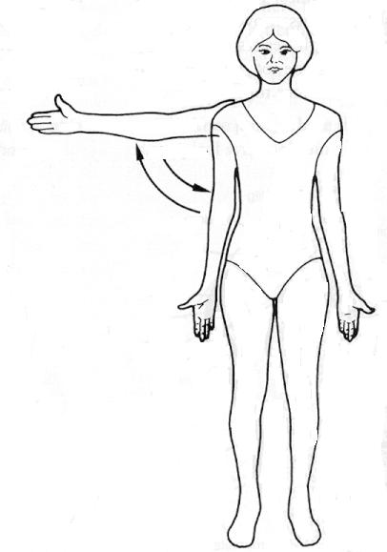

  - Flexion and extension.
  - Abduction and adduction.
  - Pronation and supination.
  - Rotation

- There are a number of phases with in a female’s menstrual cycle. The period of ovulation occurs during:
  - Days 13 – 15.
  - Days 1 – 4.
  - Days 21 – 28
  - Days 16 – 20

END OF MULTIPLE CHOICE SECTION.

Name: TEACHER:

YEAR 11 SEMESTER TWO 2003

HUMAN BIOLOGY EXAMINATION

SECTION B: SHORT ANSWER SECTION.

- Fill in all answers in this booklet.
- Spelling and grammar will count towards your mark.
- This section is worth 80 marks.
- Good luck.

MARKING AND MARK ALLOCATION

PART 1: /80
PART 2: /80
PART 3: /40

TOTAL: /200

SECTION B: SHORT ANSWERS – 10 QUESTIONS

Answer all of the questions in the spaces provided.

41 a. Label the diagram showing a longitudinal section through a long bone.
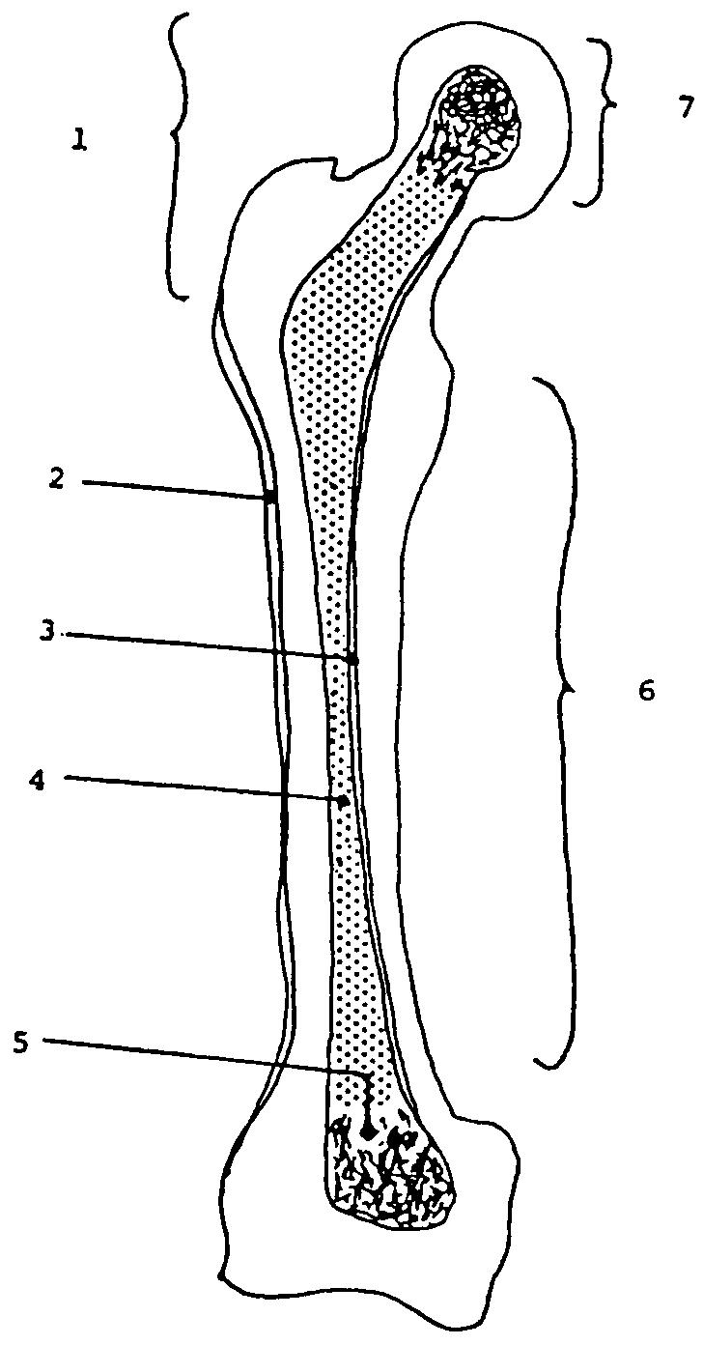
1. _________________________

2. _________________________

3. _________________________

4. _________________________

5. _________________________

6. _________________________

7. _________________________

[3.5 marks]

41 b. Name the bone shown in the diagram.
___________________________________________________________
[1 mark]
41 c. What are the three main functions of the human skeleton?

(i) ___________________________________________________________
___________________________________________________________
(ii) ___________________________________________________________
___________________________________________________________
(iii) ___________________________________________________________
___________________________________________________________
[3 marks]
41 d. Name any two muscles attached to this bone.
___________________________________________________________
___________________________________________________________
[1 mark]
41 e. Name the type of joint formed by Label 7 on the diagram.
___________________________________________________________
[0.5 mark]
41 f. The skeleton is divided into two main parts. Which part of the skeleton does this bone belong to?
___________________________________________________________
[1 mark]
41 g. What type of tissue is bone?
___________________________________________________________
[1 mark]

42. a. Use the diagram below to identify structures A – H.
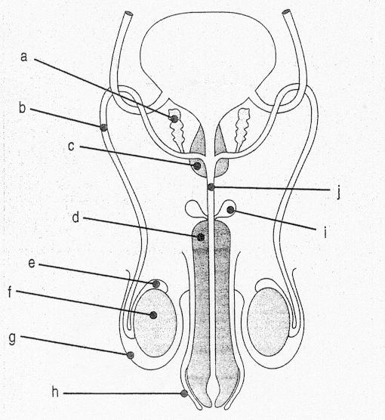

A _________________________ E _________________________
B _________________________ F _________________________
C _________________________ G _________________________
D _________________________ H _________________________
[4 marks]

42 b. What is the function of structure G?

___________________________________________________________
___________________________________________________________
___________________________________________________________
[1 mark]
42 c. Describe two main functions of semen?
___________________________________________________________
___________________________________________________________
___________________________________________________________
[2 marks]
42 d. Describe how structure D allows the process of erection to occur.
___________________________________________________________
___________________________________________________________
___________________________________________________________
[1 marks]

43 a. Using the table below, plot the figures of each 17 year old onto the graph paper below. Make clear which curve belongs to which person. [4 marks]

TIME IN MINUTES AFTER 5 MINUTES VIGOROUS EXERCISE | 17 YEAR OLD  REGULAR SMOKER BREATHS/MINUTE | 17 YEAR OLD  NON-SMOKER BREATHS/MINUTE
0 | 44 | 30
1 | 39 | 22
2 | 35 | 18
3 | 32 | 16
4 | 28 | 15
5 | 25 | 13
6 | 22 | 12
7 | 20 | 12
8 | 18 | 12
9 | 18 | 12
10 | 18 | 12

43 b. What was the normal breathing rate for each 17 year old?
___________________________________________________________
___________________________________________________________
[1 mark]
43 c. Name two variables not taken into account in this experiment and explain why they are significant.
___________________________________________________________
___________________________________________________________
___________________________________________________________
___________________________________________________________
[2 marks]
44 a. Label the structures A – D from the diagram below.
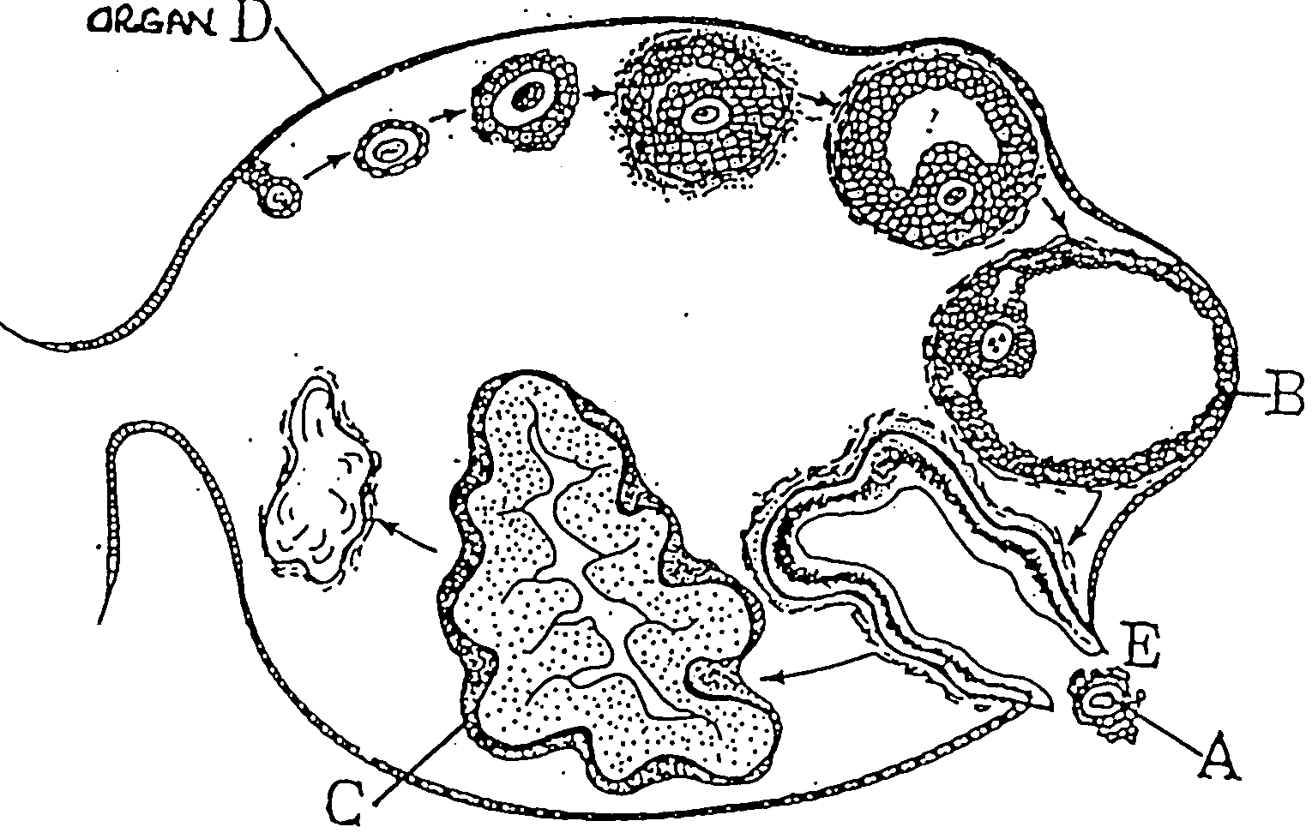

A ________________________________________
B ________________________________________
C ________________________________________
D ________________________________________
[2 marks]
44 b. Structure B develops under the influence of a hormone.
(i) Name this hormone ______________________________________________
(ii) From where is it secreted? ________________________________________
[2 marks]
44 c. Structure C secretes a hormone.
(i) Name this hormone ______________________________________________
(ii) Name one effect of this hormone ___________________________________
[2 marks]

44 d. What does stage E represent?
___________________________________________________________
[1 mark]
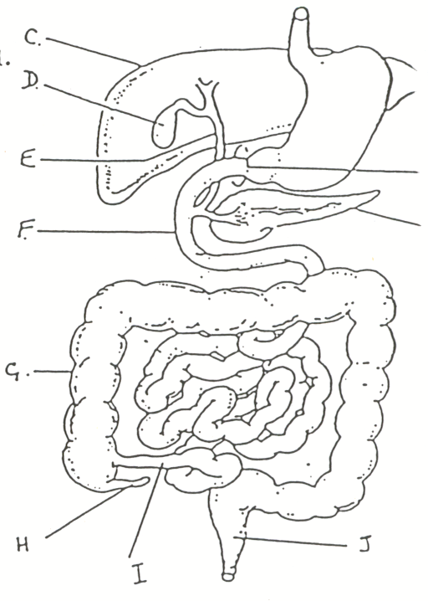
46 a. Study the diagram of the digestive system below and provide labels for the structures listed.
A
BG

A ____________________________
B ____________________________
C ____________________________
D ____________________________
E ____________________________
F ____________________________
G ____________________________
H ____________________________
I ____________________________
J ____________________________
[5 marks]
46 b. Give the functions of structures D and I.
D ___________________________________________________________

I ___________________________________________________________
[2 marks]

46 c. Explain why little or no carbohydrate digestion occurs in the stomach.
___________________________________________________________
___________________________________________________________
___________________________________________________________
[1 mark]
46 d. Explain the role of the pancreas in lipid digestion.
___________________________________________________________
___________________________________________________________
___________________________________________________________
___________________________________________________________
[2 marks]
46 e. Give two functions of structure C other than the production of bile.
___________________________________________________________
___________________________________________________________
___________________________________________________________
___________________________________________________________
___________________________________________________________
[2 marks]

46 f. Label the diagram below of a villus.
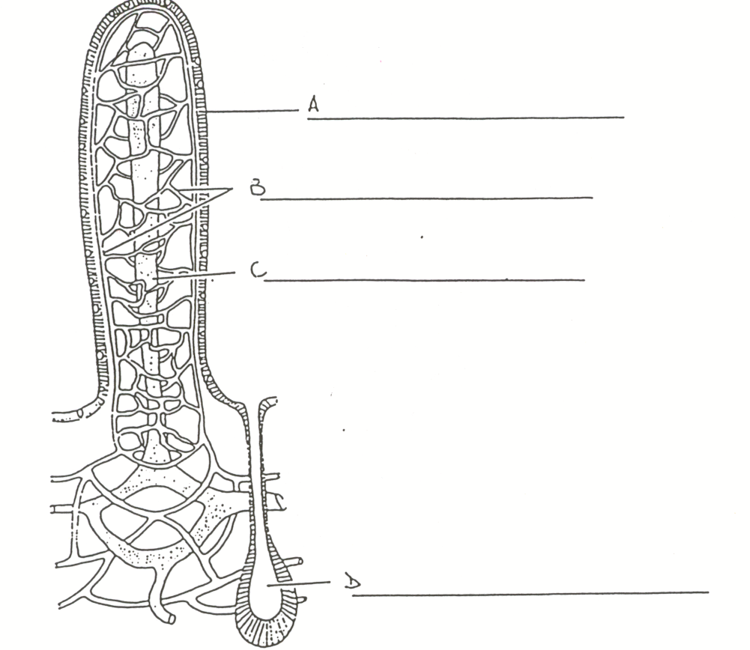

[4 marks]

46 g. Describe two ways a villus helps in the absorption of digested food.

- ___________________________________________________________
- ___________________________________________________________
[2 marks]
46 h. Name and describe the process used to move food through the alimentary canal.
___________________________________________________________
___________________________________________________________
[1 mark]

47 a. Name the two hormones involved in feeding breast milk to a baby

i ___________________________________________________________
ii ___________________________________________________________
[2 marks]
47 b. Give two reasons why bottle feeding is better for a baby than bottle feeding.

i ___________________________________________________________
ii ___________________________________________________________
[2 marks]

Question 48 refers to the diagram below
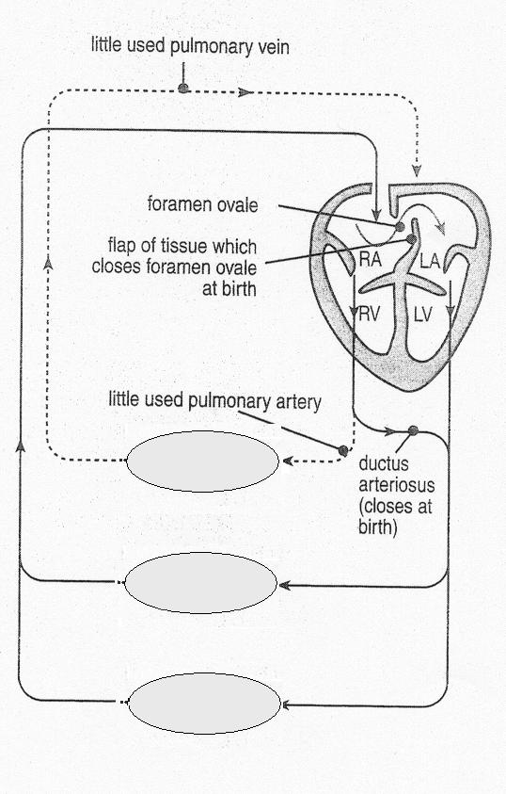

A
E

C
B

Other Tissues

D

48 a. Identify

A ___________________________________________________________
B ___________________________________________________________
C ___________________________________________________________
D ___________________________________________________________
[2 marks]

48 b. Why are A and B necessary in foetal circulation?

___________________________________________________________
___________________________________________________________
___________________________________________________________
___________________________________________________________
___________________________________________________________
___________________________________________________________
[2 marks]

48 c. What structural changes take place in the foetal heart at the time of birth?

___________________________________________________________
___________________________________________________________
___________________________________________________________
___________________________________________________________
___________________________________________________________
___________________________________________________________
[1 mark]

49 a. During the embryo stage of development the cells of the embryo differentiate into 3 primary tissue layers; the endoderm, mesoderm and ectoderm.

List 2 body tissues in the fully developed human body that originated from each primary tissue layer in the foetus.

ENDODERM (i) ____________________________________
(ii) ____________________________________
MESODERM (i) _____________________________________
(ii) _____________________________________
ECTODERM (i) _____________________________________
(ii) _____________________________________
[3 marks]
49 b. During which weeks of pregnancy is the embryo stage?

___________________________________________________________
[1 mark]

49 c. The embryological stage is the most crucial in terms of physical deformities in the developing embryo. What is the name given to those agents in the environment that can cause physical abnormalities?

___________________________________________________________
[1 mark]
49 d. Give 4 examples of these agents and describe two effects of each.

___________________________________________________________ ___________________________________________________________
___________________________________________________________
___________________________________________________________
___________________________________________________________
___________________________________________________________
___________________________________________________________
___________________________________________________________
[2 marks]
50 a. Complete the table below.
[6 marks]
SUBSTANCE | SITE OF PRODUCTION | EFFECTS
Prolactin

Oxytocin

Colostrum.

50 b. What are the two types of myofibrils found in skeletal muscle?
__________________________________
__________________________________
[2 marks]
50 c. Describe how myofibrils work together to cause muscle contraction. Include a labelled diagram with your answer.

___________________________________________________________
___________________________________________________________
___________________________________________________________
___________________________________________________________
___________________________________________________________
___________________________________________________________
___________________________________________________________
___________________________________________________________
___________________________________________________________
___________________________________________________________
___________________________________________________________
___________________________________________________________
___________________________________________________________
___________________________________________________________
[4 marks]

END OF PART B



SCIENCE

NAME : _______________________________

Please indicate your answer with a cross (X) within the box.

1 | A | B | C | D | E |  | 21 | A | B | C | D | E
2 | A | B | C | D | E |  | 22 | A | B | C | D | E
3 | A | B | C | D | E |  | 23 | A | B | C | D | E
4 | A | B | C | D | E |  | 24 | A | B | C | D | E
5 | A | B | C | D | E |  | 25 | A | B | C | D | E
6 | A | B | C | D | E |  | 26 | A | B | C | D | E
7 | A | B | C | D | E |  | 27 | A | B | C | D | E
8 | A | B | C | D | E |  | 28 | A | B | C | D | E
9 | A | B | C | D | E |  | 29 | A | B | C | D | E
10 | A | B | C | D | E |  | 30 | A | B | C | D | E
11 | A | B | C | D | E |  | 31 | A | B | C | D | E
12 | A | B | C | D | E |  | 32 | A | B | C | D | E
13 | A | B | C | D | E |  | 33 | A | B | C | D | E
14 | A | B | C | D | E |  | 34 | A | B | C | D | E
15 | A | B | C | D | E |  | 35 | A | B | C | D | E
16 | A | B | C | D | E |  | 36 | A | B | C | D | E
17 | A | B | C | D | E |  | 37 | A | B | C | D | E
18 | A | B | C | D | E |  | 38 | A | B | C | D | E
19 | A | B | C | D | E |  | 39 | A | B | C | D | E
20 | A | B | C | D | E |  | 40 | A | B | C | D | E

Name: TEACHER:

YEAR 11 SEMESTER TWO 2003

HUMAN BIOLOGY EXAMINATION

SECTION C: EXTENDED ANSWERS

- Fill in the answers to your essays in this booklet.
- Number your questions appropriately.
- All answers are to be written in blue or black biro pen.
- Diagrams are to be done in pencil with labels.
- Spelling and grammar count towards your final mark.
- Good luck!!

SECTION C – ESSAYS – 40 MARKS.

Choose ONE question from Q.51 and ONE from Q.52 below. Marks will be deducted for spelling and poorly structured answers. Illustrate your answers with diagrams, where appropriate.

Q.51 A

(a) The human body uses a number of hormones that are released for reproduction. Explain in detail the hormones released, the target organ and the effect of each hormone.
[12]

(b) The liver plays a very important part in human digestion. Discuss the functions of the liver in the human body.
[8]

OR

Q.51 B

(a) Explain how the milk let-down reflex is used in taking care of a newborn baby.
[4]

(b) Discuss the signs and symptoms of fractures.
[4]

(c) The foetus goes through a number of changes from third month to the ninth month of its development. Give a monthly account of the stages of development of a foetus during this time.
[12]

Q. 52 A

(a) During foetal development there a number of environmental factors that can cause non-inheritable changes. Give a full account of these factors and explain how each can contribute to birth defects.
[10]

(b) Explain how osmosis works. Use a diagram to illustrate your answer.
[2]

(c) In this modern age, many people are affected by heart disease. Give examples of the different types of heart diseases and explain how they affect the heart.
[8]

OR

Q. 52 B

(a) The human body is well articulated with fixed, slightly movable and freely movable joints. Draw an example of each one and give an explanation of its function in the body.
[6]

(b) All body cells use mitosis for replication except our gametes which use meiosis. Explain (with the use of diagrams)each of the stages of meiosis.
[8]

(c) Describe in detail the three stages of labour.
[6]

